Maliyet Hesabı

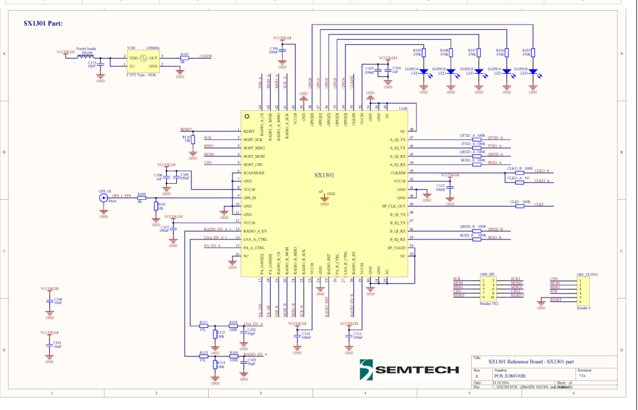

SX1301IMLTRT

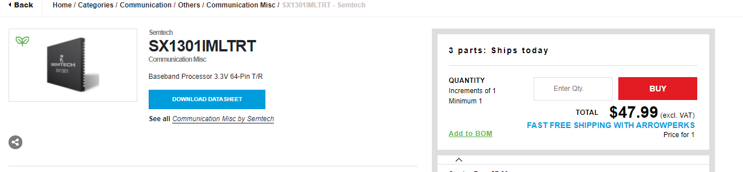
- SX1257IWLTRT
https://www.micro-semiconductor.com/products/Semtech/SX1257IWLTRT
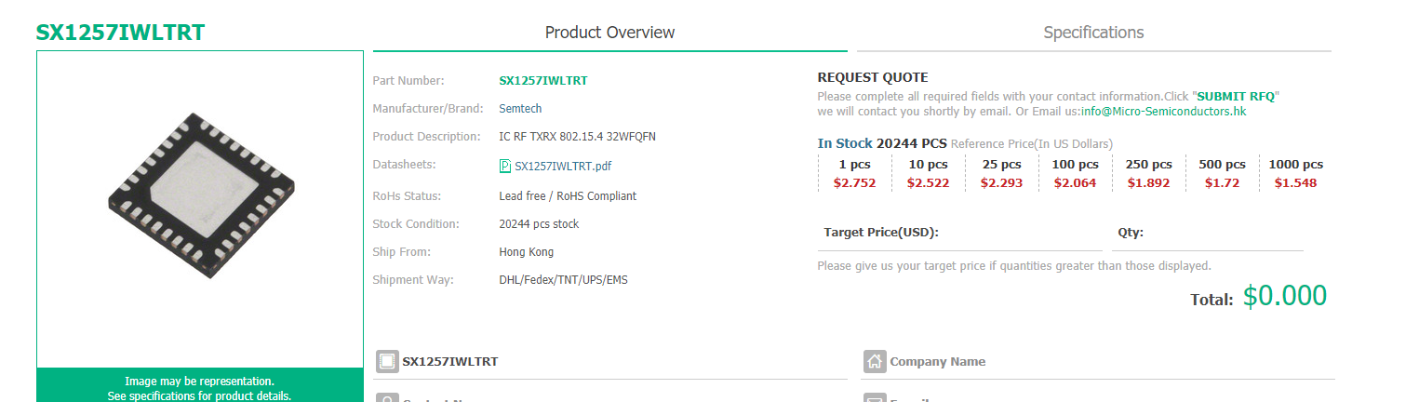

- ferrite bead: bildiğimiz indüktanstır. özellikle digital devrelerde çiplerin besleme hattı üzerine bindireceği yüksek frekanslı gürültüleri süzmek için kullanılır.

LF-35B(B15) 120OHM/100MHz Ferrit X3
https://www.direnc.net/lf-35bb15-120ohm-100mhz-ferrit?language=tr&h=eb73bf95&gclid=Cj0KCQjw0K-HBhDDARIsAFJ6UGgEa5BBmVecz0CVvCpQ_LygXnawOUn4J1uyMDBgT_ZMv6Etwczvi9caArxHEALw_wcB
8,77 TLKDV Dahil
https://www.alibaba.com/product-detail/Ferrite-VIIP-Factory-Supplier-NiZi-Environmentally_1600136824698.htmlspm=a2700.7735675.normal_offer.d_title.41ed747ahLrKjN&s=p
1000-9999Pieces
$0.28
>=10000 Pieces
$0.21

- 2725T-133 MHZ-ENA4643A
https://www.digikey.com/en/products/detail/ndk-america-inc/2725T-133MHZ-ENA4643A/9171987

QTY | UNIT PRICE | EXT PRICE
1 | $2.72000 | $2.72
10 | $2.65600 | $26.56
50 | $2.53000 | $126.50
100 | $2.21380 | $221.38
500 | $2.15050 | $1,075.25

- GPS SMA

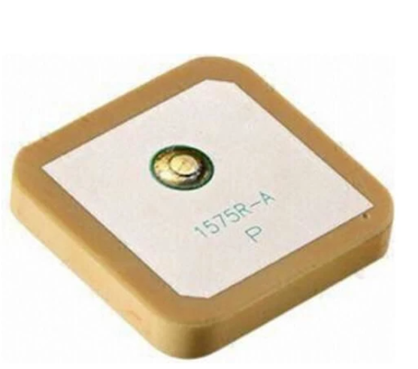

https://www.hepsiburada.com/kls-electronic-gps-sma-anten-5dbi-p-HBCV00000DQKH2?magaza=direnc

16,68 Tl

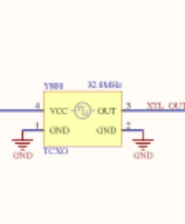

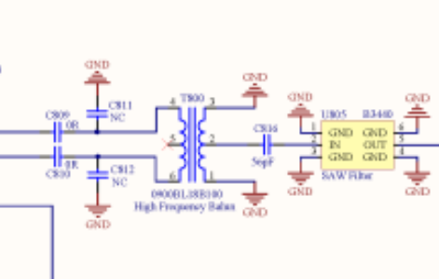

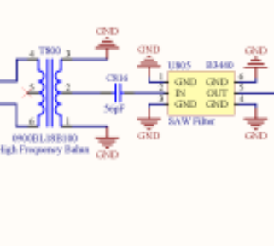

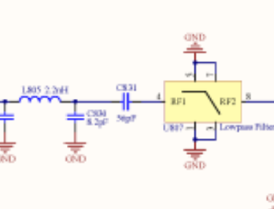

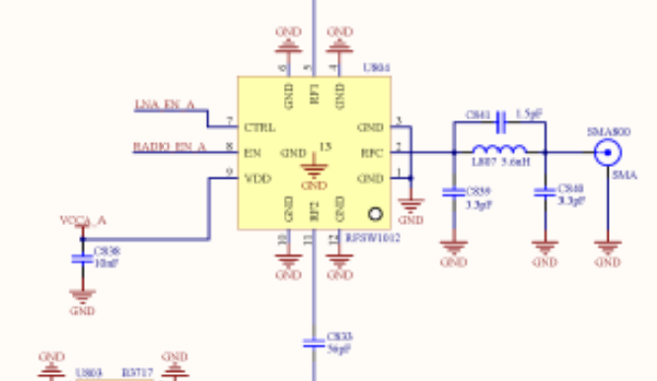

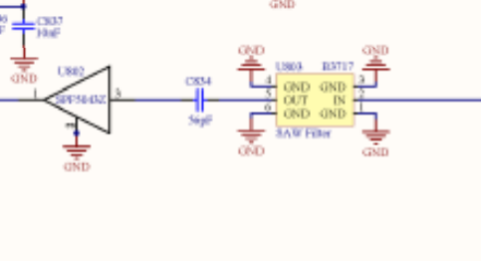

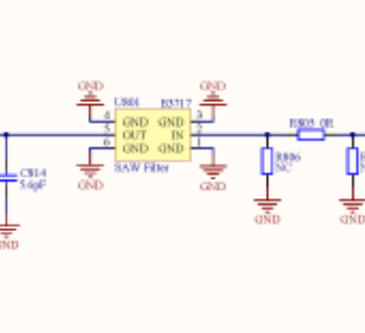

SX1301IMLTRT 48 DOLAR

SX1257IWLTRT 2.75 DOLAR X2 = 2.5 DOLAR

LF-35B(B15) 120OHM/100MHz Ferrit 0.74 DOLAR X 3 = 2.20 DOLAR

- 2725T-133 MHZ-ENA4643A 2.72 DOLAR

TOPLAM 55.42 DOLAR=479 Tl
- GPS SMA 16.68 TL
TOPLAM 495 Tl

